User Guide 53 Using LASSI-SPEAR
Purpose of this User Guide
The purpose of this User Guide is to provide information on how to use the LASSI-SPEAR application.
Who should read this guide?
Primary audience: Applicant, Land Use Victoria users and the Public
For information: Other SPEAR users
Introduction
LASSI-SPEAR is a free web mapping application that allows you to search and download survey information from one location. It incorporates a web map search interface based on LASSI with the added functionality of being able to download survey documents and the ability to download pre-populated ePlans with data from Vicmap and SMES. This user guide only covers the functionality unique to the LASSI-SPEAR application.
For information on using the common LASSI functions, please refer to the Guide to Land and Survey Spatial Information found here.
- How to start using LASSI-SPEAR
LASSI-SPEAR is available free of charge from the following URL
https://www.spear.land.vic.gov.au/lassi/SpearUI.jsp or from your SPEAR portal.
The website can also be found by clicking the LASSI menu on the SPEAR home page then the LASSI-SPEAR link.
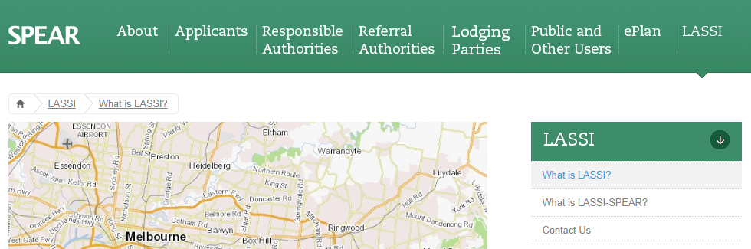
Otherwise, if you’re logged in to SPEAR it can be accessed by clicking the LASSI-SPEAR link located at the top right corner of the Application List screen.
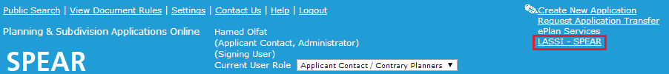

- Download Survey Documents / Survey Mark Reports
In LASSI, the Pan tool (shown pictured to the left) is solely used for moving the map around with the mouse. In LASSI-SPEAR it has an additional function.
With the Pan tool active, PDF survey documents and survey mark reports can be viewed by clicking the associated label on the map. The associated map layer must be turned on for the labels to appear. For example, to view permanent mark labels, ensure the ‘Survey Marks’ layer is ticked.
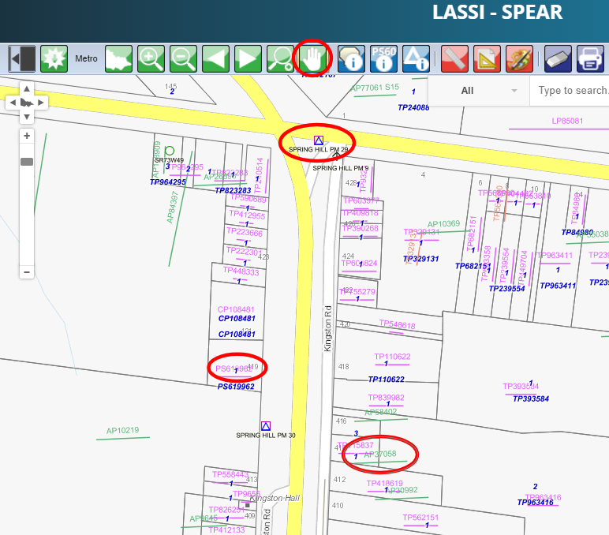
NOTE: When a survey mark label is clicked (when ‘Pan’ is active), a ‘survey mark full report’ will be shown.

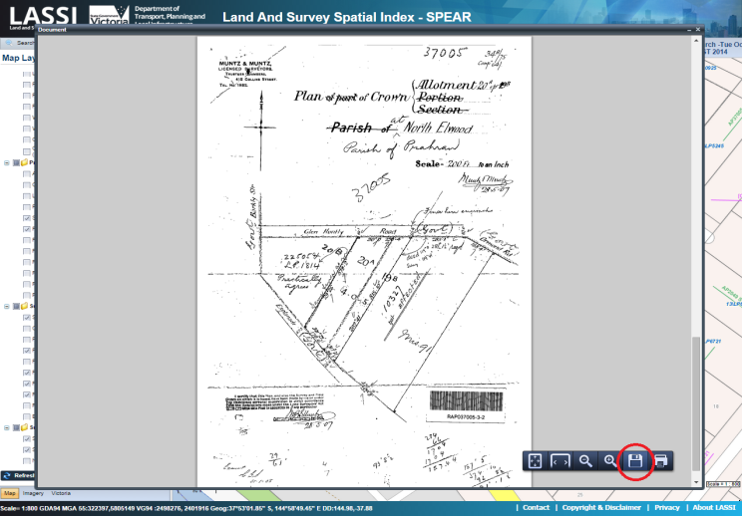
The PDF Preview window is displayed when a label is clicked. Different browsers use different PDF viewers, but there should be options for saving the file locally and printing the document.

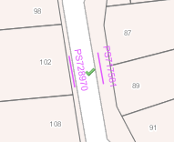
When clicking on labels, the label is marked with a green tick to indicate that the associated document has been viewed, as well as any other label that shares the same value. e.g. If you click on survey label PS654321A to download the survey file, all PS654321A labels will have a green tick next to them.

Some labels will return messages that the documents cannot be found. In these cases, the documents may have been lost, or potentially not imaged yet. These may be held at the Land Use Victoria offices, and if you require these documents, you may contact LASSI support at lassi.info@delwp.vic.gov.au to request them.

- Moving between searches
Like the basic functions of a web browser, these buttons allow you to move backwards and forwards between your searches easily without requiring the manual input of search parameters, or manually zooming/panning between locations.

- Using Activate Document Download Tab tool
The Document tab is opened when the Activate Document Download Tab tool is clicked on the toolbar. This shows a list of available survey labels within the current view and provides multiple options for accessing these documents.
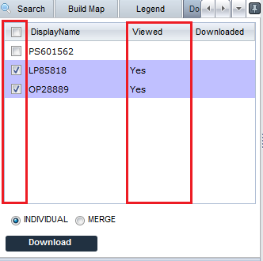
In the Viewed column within the Document tab, the value ‘Yes’ is represented for any survey document that has been already viewed by you using the Download Survey Documents tool shown in 53.02, or ‘N/A’ for any that were unable to be located.
To download the documents to your computer, click the check boxes of the survey information you’re interested in, select either ‘Individual’ or ‘Merge’ then click ‘Download’. By selecting the ‘Individual’ button, the documents will be downloaded as individual PDFs bundled in a zip file. Selecting ‘Merge’ will download them as one combined PDF.

- How to select and download digital data?
Digital spatial data can be selected and downloaded in ePlan format (known as Cadastral Infrastructure Search – CIS) for import into surveying software packages.
The downloaded file includes the information of administrative areas (LGA and Parish), datum, survey marks (PMs and PCMs), parcels, road abuttals, and location addresses. To select an area to download, use the Draw Polygon to Export Survey Information to LandXML tool to draw a polygon over the desired area.
The Digital Data tab indicates the location information and survey marks that have been selected.
The list of survey marks is populated from all the survey marks displayed on the map display panel. Zoom out or pan to be able to see more survey marks in the map display panel. Click ‘Download’ for the digital file. The image below shows how the file is downloaded in the browser.
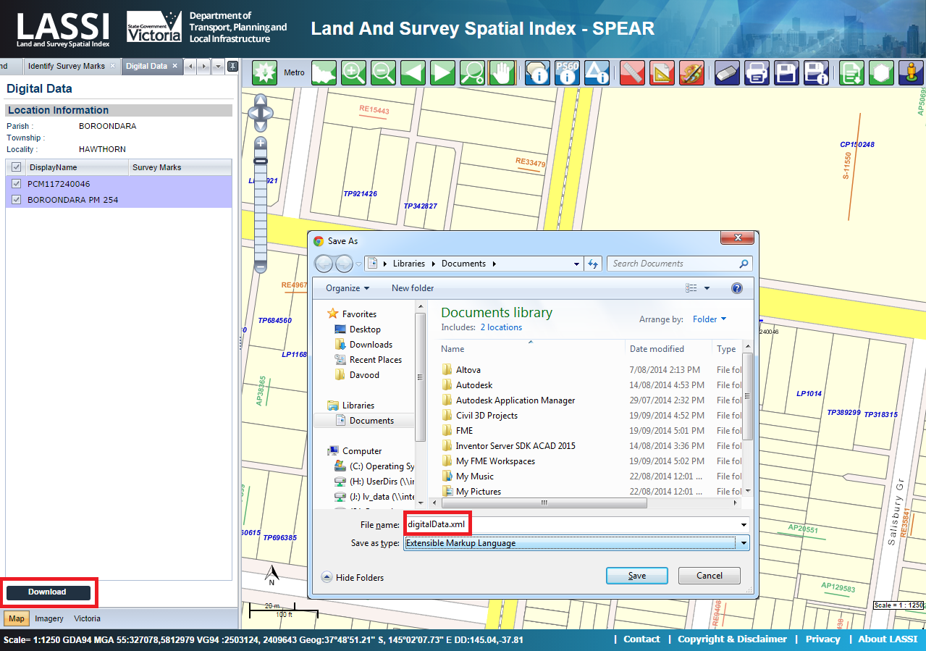

If you have drawn a polygon and there are no survey marks or location information shown in the list in the Digital Data tab you can still click ‘Download’ and it will download all the parcel information in LandXML format which can then be imported into your supported surveying software package for visualisation.
Need more information?
Further information on this topic can be found by:
- Visiting the SPEAR website www.spear.land.vic.gov.au/spear
- Contacting the SPEAR Service Desk on 9194 0612 or email spear.info@delwp.vic.gov.au

